**Customer Churn Analysis Summary**

**Dataset Overview:**

* Total Records: 7,043 customers
* Columns: 21 features including demographic info, service usage, billing, and churn status.

**Churn Rate**

* Total Churned Customers: 25.54%
* About 1 in 4 customers have left the service, a significant figure indicating the need for churn control measures.

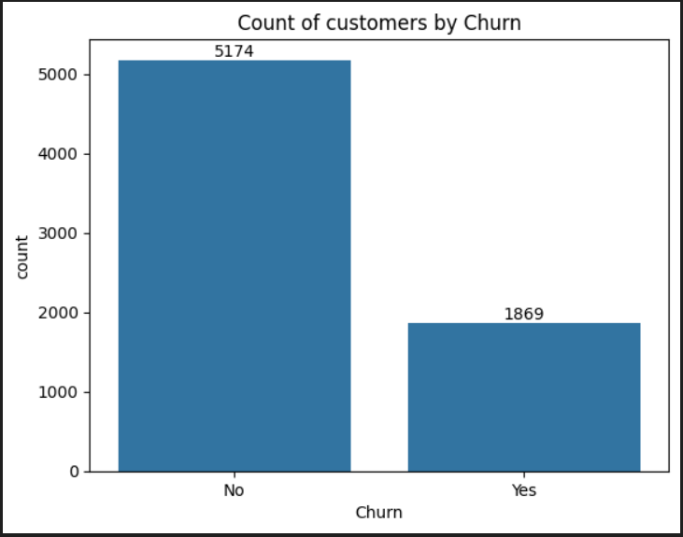

Key Factors Influencing Churn

**Senior Citizens**

Senior Citizens churn more than non-senior citizens which Indicates that age group may influence customer satisfaction or tech adaptation.

**Tenure**

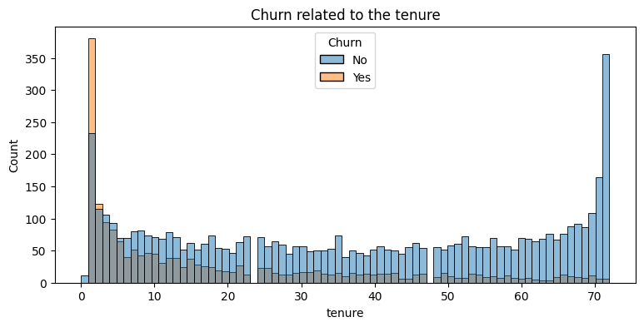Most churn occurs early in the customer lifecycle. Customers who stay longer tend to be more loyal. Retention focus should be on early months.

**Contract Type**

* Month-to-month contracts have the highest churn rate.
* Customers with 1- or 2-year contracts churn significantly less.
* 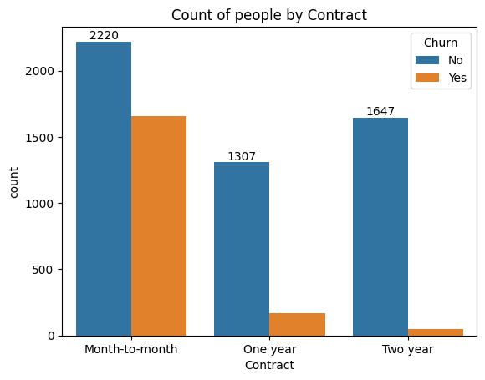Suggests that long-term commitment reduces churn.

**Internet Service**

* Fiber optic users churn more than DSL users.
* No internet service = least churn, likely due to minimal usage.

**Value-Added Services**

Customers not using services like:

* OnlineSecurity
* OnlineBackup
* DeviceProtection
* TechSupport

have higher churn rates. These services help reduce churn by increasing customer engagement and satisfaction.

**Streaming Services**

Customers using StreamingTV and StreamingMovies churn less. Entertainment features likely enhance perceived value of the service.

**Phone and Multiple Lines**

Customers without PhoneService or MultipleLines are more likely to churn. However, their share in the total population is small.

**Payment Method**

Customers paying via electronic check show significantly higher churn. Other payment methods (like credit cards or bank transfer) have lower churn rates.

**Conclusion**

Customer churn in this telecom dataset is influenced by contract type, engagement with services, and payment method.

**Strategies to reduce churn:**

* Encourage long-term contracts.
* Promote value-added services like security and backup.
* Offer incentives for early-tenure retention.
* Investigate service quality issues, especially with fiber optic internet.
* Consider revising options for electronic check users, possibly by educating or offering alternatives